

**Mini Project Report On**

**Online Food Ordering System**

Submitted by

Mayur Pingale

1032180083

Rohit Patil 1032180216

Karan Patil 1032180232

Kunal Patil 1032180366

**Under the Guidance of**

**Prof. Pradnya Kulkarni**

**School of Computer Engineering and Technology**

**MIT World Peace University, Kothrud,**

**Pune 411 038, Maharashtra - India**

**2020-2021**

**Abstract**

Online food ordering system ensures that the customers are at ease. It overcomes the disadvantages of the traditional food ordering system. Our system is a medium to order online food hassle free from restaurants as well as mess service. This system improves the method of taking the order from customer. The online food ordering system has a food menu set up online and customers can easily place the order as per their wish. This system also provides a feedback system. For more secured ordering separate accounts are maintained for each user and manager by providing them an ID and a password.

**Contents**

|  |  |  |
| --- | --- | --- |
| 1 | Introduction | |
| 2 | Problem Definition | |
| 3 | Database Design | |
| 4 | GUI | |
| 5 | PHP Session Handling Details | |
| 6 | Conclusion | |
| 7 | Bibliography in IEEE Format | |
| 8 | Appendix | |
|  | A | Tools Used |
|  | B | References |
|  | C | Plagiarism Report |

**List of Figures**

3.1 ER Diagram of Database

4.1 Home Page

4.2 About

4.3 Contact

4.4 Customer Login

4.5 Manager Login

4.6 Customer Signup

4.7 Manager Signup

4.8 Food Zone

4.9 Cart (i)

4.10 Cart (ii)

4.11 Payment

4.12 Credit card payment

4.13 Cash on delivery

4.14 Manager Interface (i)

4.15 Manager Interface (ii)

4.16 Email validation

4.17 Contact validation

8.1 Scan Report

1. **Introduction**

With the advancement of technology, you don't just simplify the lives of your customers, but also ensure that your business is able to stand tall in the competitor market.

In the current scenario, consumers have come to expect the ability of a restaurant to allow them to place orders online. Some advantages of online food ordering –

1. Makes the ordering process easier

Placing an order through a phone call means that there could be mistakes while placing the order. For people with busy lifestyles, these aren't really the best solutions to order food from restaurants.

Having an online food ordering system makes the operations more efficient for a restaurant. When a customer places an order online, they can take their time to browse the menu and get familiar with all the deals and offers that a restaurant must be offering.

1. Monitor your expenses incurred in real time

An online food ordering system can gives precise information about the cash flow in the restaurant. It helps to keep track of costs incurred during preparing an order and compare it to the cost you are giving it to the customer.

1. Free and cheap marketing

Having a presence online means being in front of your customers at all times,without having to pay for expensive media advertising and billboards. All this comes at a fraction of the cost that would have spent on other means of marketing and promotions.

1. The convenience of Mobile Ordering

Online food ordering allows customers to order anytime, anywhere using their mobiles. There isn’t any need for the customer to reach out and make a call while disturbing their privacy or disrupting a meeting for an order.

1. Greater Reach

A restaurant seating capacity is limited at a time, maybe 200-300 or even less, but with online ordering, you can reach thousands of people at a time, without having to make any additional investment in staff or infrastructure.

1. **Problem Definition**

Food Ordering System is an application which will help restaurant to do all the functionalities in a more accurate and faster way. The main function of the system is to maintain the restaurant’s functions in an effective and accurate manner, at the same time also reducing the amount of manual work. This system helps restaurants provide food orders to customers and maintains records in a system by keeping proper record in database.

1. **Database Design**

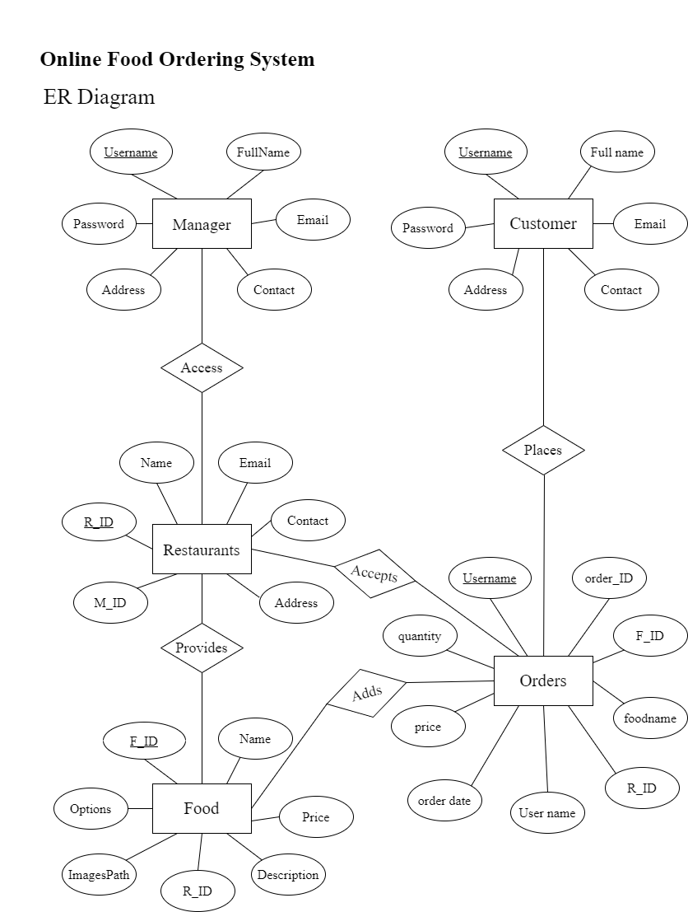

Fig 3.1 – ER Diagram of Database

1. **GUI with client side validations**

**HOME –**

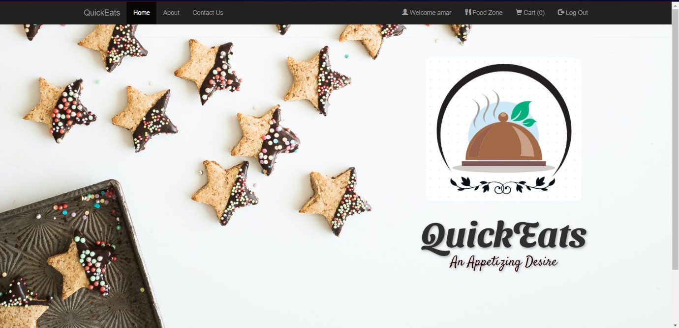

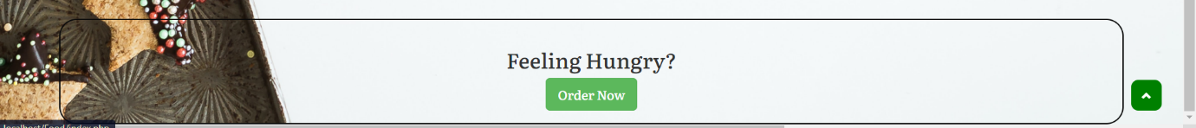

Fig 4.1 – Home Page

**ABOUT –**

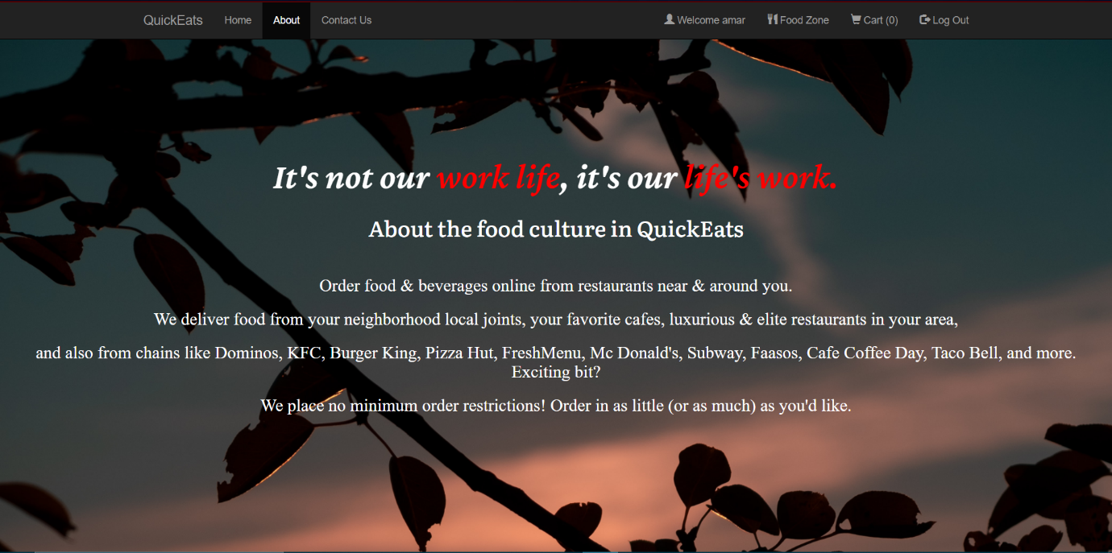

Fig 4.2 – About

**CONTACT –**

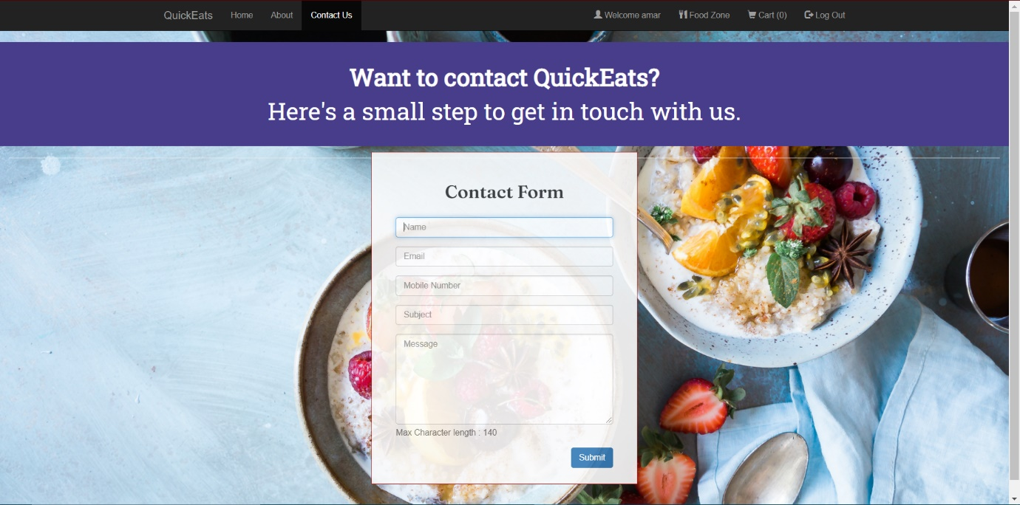

Fig 4.3 – Contact

**CUSTOMER LOGIN –**

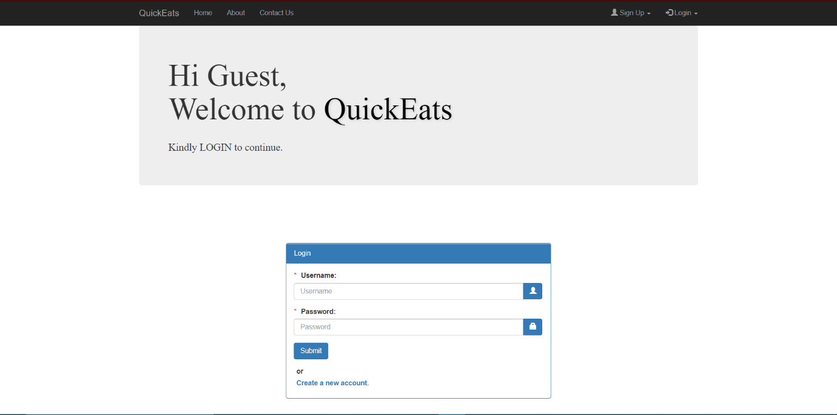

Fig 4.4 – Customer Login

**MANAGER LOGIN –**

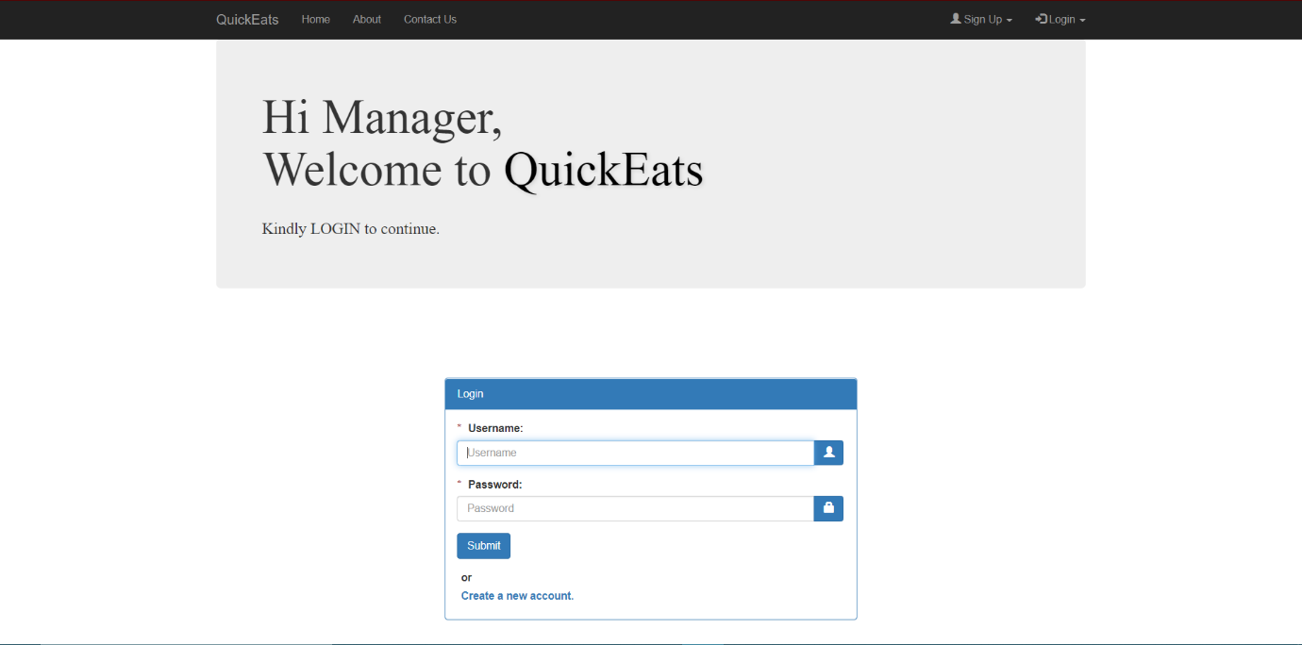

Fig 4.5 – Manager Login

**CUSTOMER SIGNUP -**

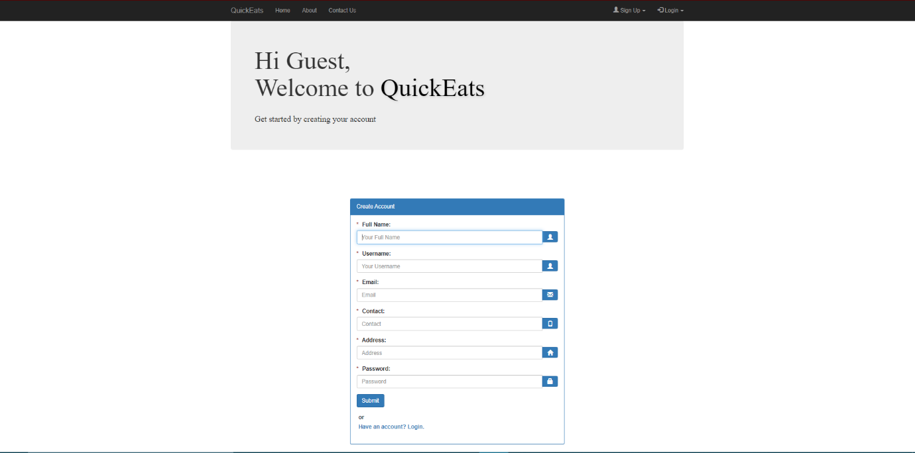

Fig 4.6 – Customer Signup

**MANAGER SIGNUP -**

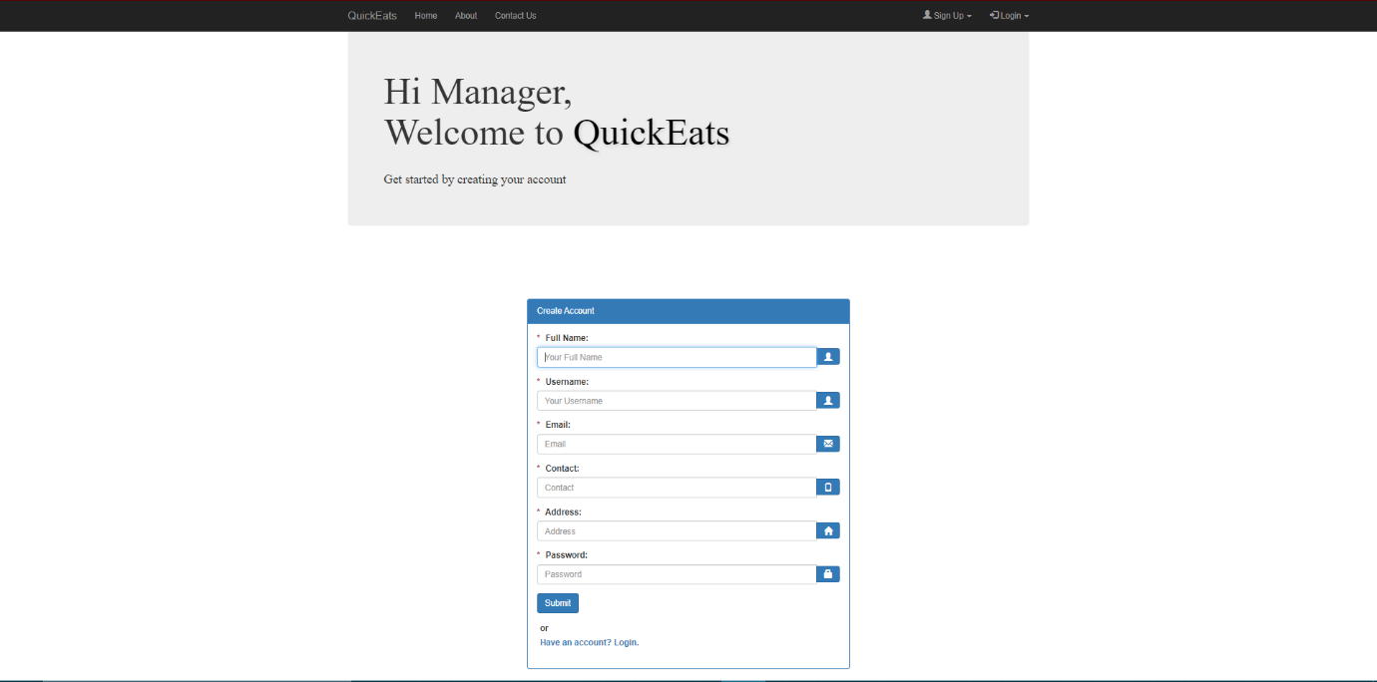

Fig 4.7 – Manager Signup

**CUSTOMER INTERFACE**

**FOOD ZONE –**

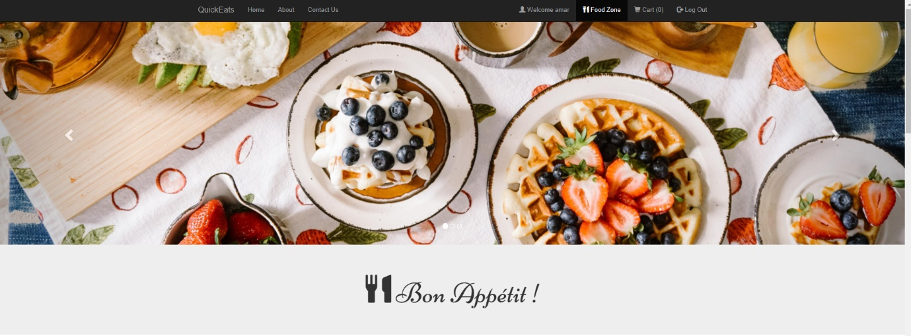

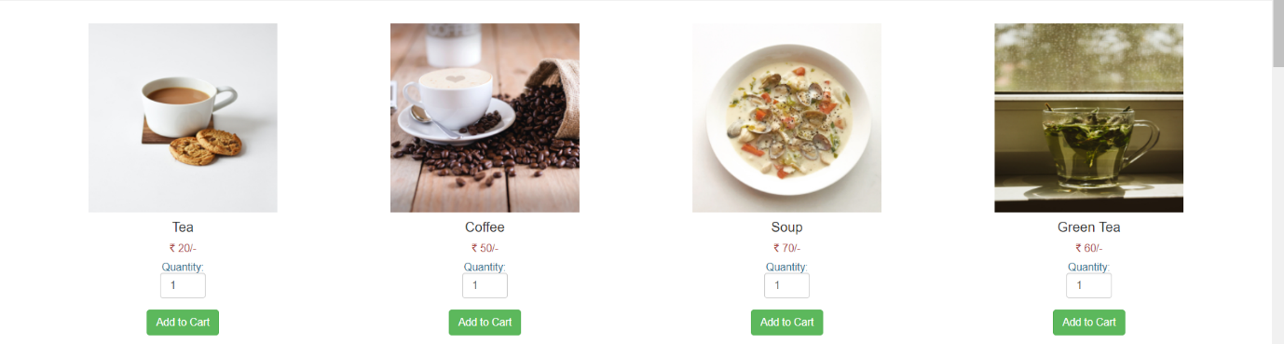

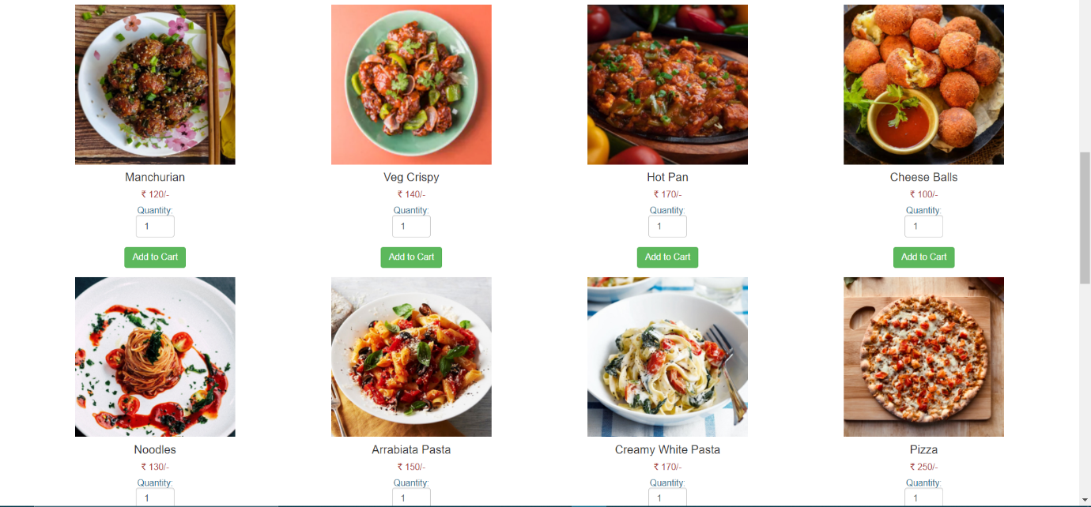

Fig 4.8 – Food Zone

**CART –**

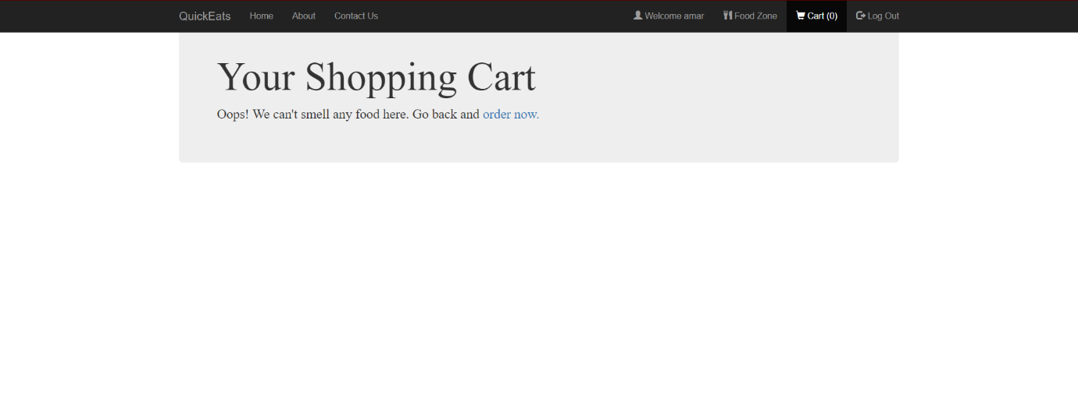

Fig 4.9 – Cart (i)

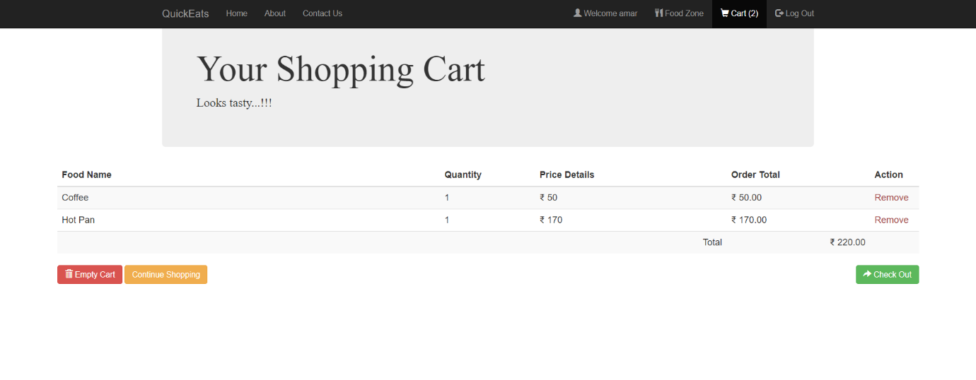

Fig 4.10 – Cart (ii)

**PAYMENT –**

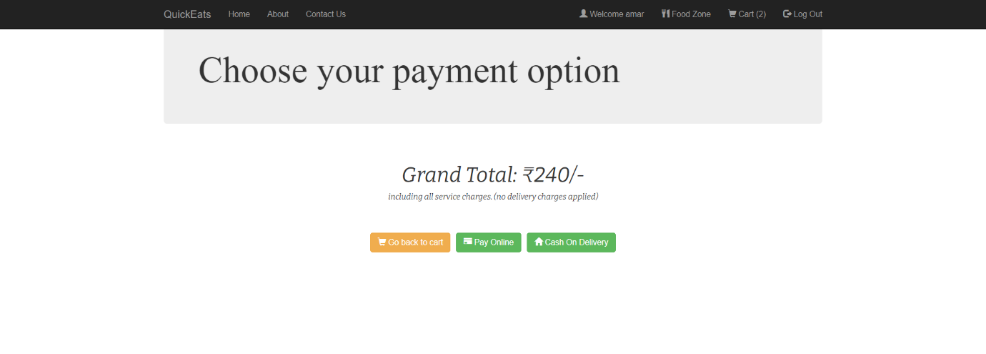

Fig 4.11 – Payment

**CREDIT CARD PAYMENT –**

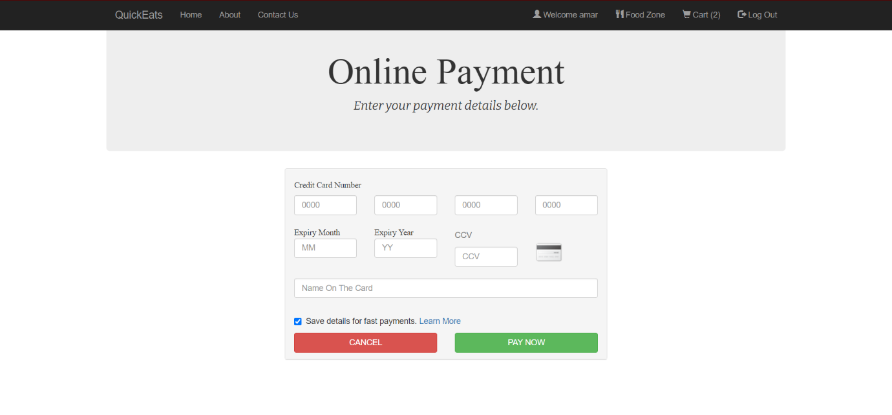

Fig 4.12 – Credit Card Payment

**CASH ON DELIVERY –**

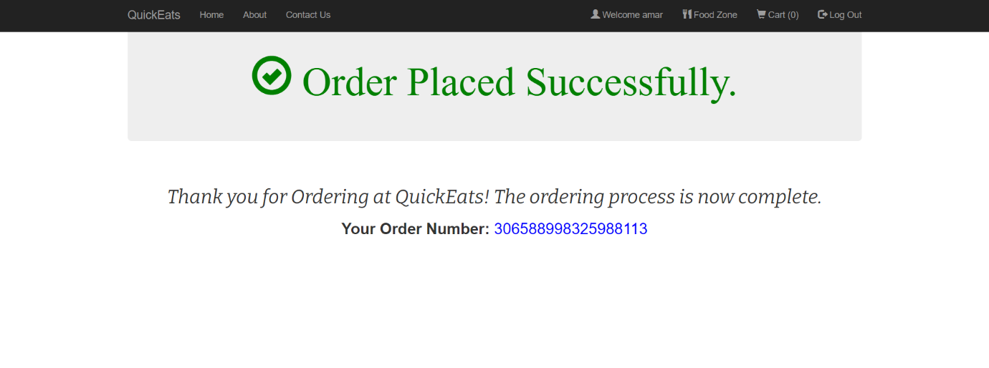

Fig 4.13 – Cash on Delivery

**MANAGER INTERFACE –**

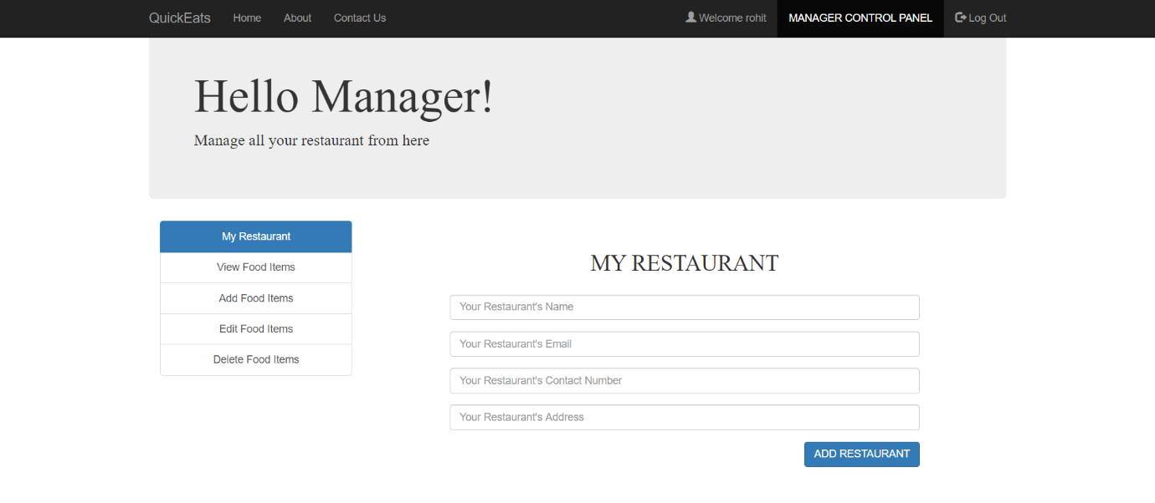

Fig 4.14 – Manager Interface (i)

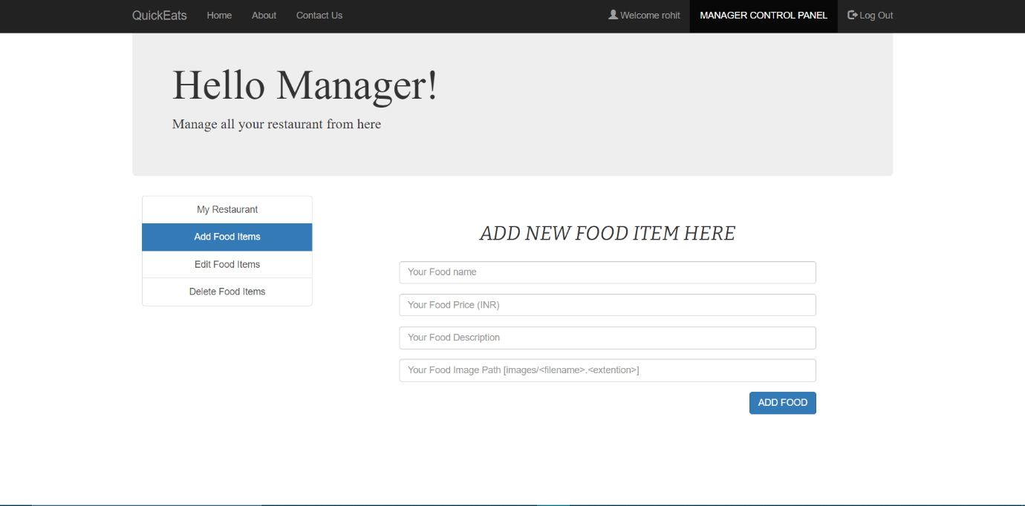

Fig 4.15 – Manager Interface (ii)

**CLIENT SIDE VALIDATIONS**

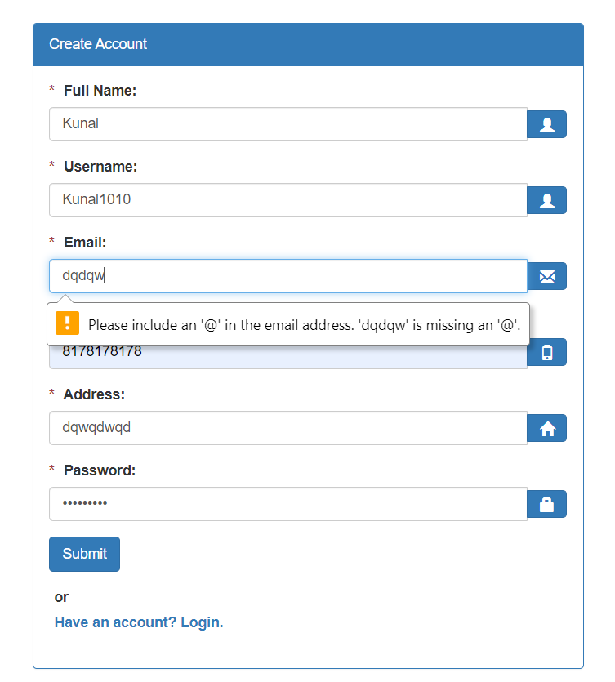

Fig 4.16 – Email Validation

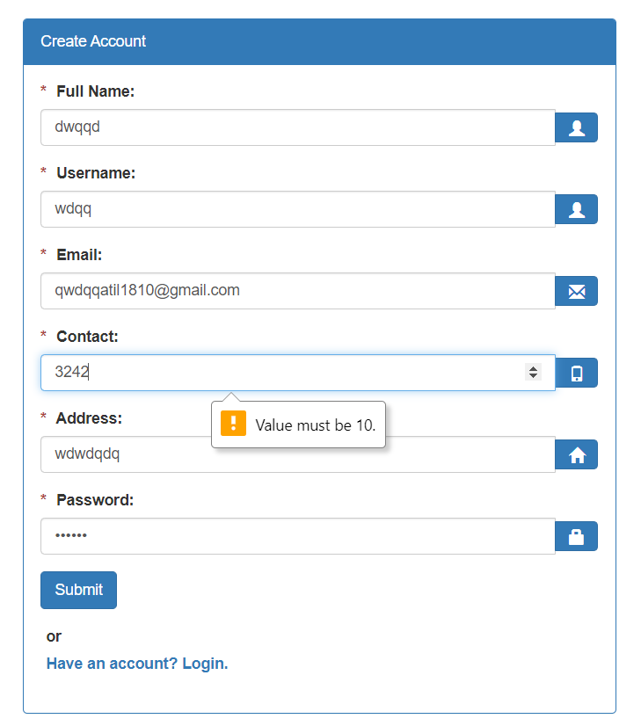

Fig 4.17 – Contact Validation

1. **PHP Session Handling details**
2. **What is a PHP Session ?**

When you work with an application, you open it, do some changes, and then you close it. This is much like a Session. The computer knows who you are. It knows when you start the application and when you end. But on the internet there is one problem: the web server does not know who you are or what you do, because the HTTP address doesn't maintain state.

Session variables solve this problem by storing user information to be used across multiple pages (e.g. username). By default, session variables last until the user closes the browser.

So; Session variables hold information about one single user, and are available to all pages in one application.

* 1. **Customer Session –**

1. $_SESSION['login_user2']=$username; // Initializing Session
2. session_start();

$user_check=$_SESSION['login_user2'];

// SQL Query To Fetch Complete Information Of User

$query = "SELECT username FROM CUSTOMER WHERE username = '$user_check'";

$ses_sql = mysqli_query($conn, $query);

$row = mysqli_fetch_assoc($ses_sql);

$login_session =$row['username'];

//Here, we are checking the user session information.

1. session_start();

if(session_destroy()) // Destroying All Sessions

header("Location: customerlogin.php"); // Redirecting To Home Page

* 1. **Manager Session –**

1. $_SESSION['login_user1']=$username; // Initializing Session
2. session_start();

$user_check=$_SESSION['login_user1'];

// SQL Query To Fetch Complete Information Of User

$query = "SELECT username FROM MANAGER WHERE username = '$user_check'";

$ses_sql = mysqli_query($conn, $query);

$row = mysqli_fetch_assoc($ses_sql);

$login_session =$row['username'];

1. session_start();

if(session_destroy()) // Destroying All Sessions

header("Location: managerlogin.php"); // Redirecting To Home Page

1. **Conclusion**

With online food ordering system, a restaurant can set up a menu online and the customers can place orders easily. The tracking the orders is done easily with a food menu online, it maintains customer’s database and improve the food delivery service. The manager of a restaurant can even customize online restaurant menu and upload images easily. Having a restaurant menu on internet, increases the reach of the business. The customers can access it easily and place orders at their convenience. Thus, online food ordering system is presented with feature of feedback.

1. **Bibliography**
2. w3schools
3. **Appendix**
4. **Tools used**

* Notepad++ Editor
* Atom IDE
* Xampp Server
* PHP MyAdmin
* MySQL 8.0 Workbench
* Google Chrome Web Browser
* Visual Studio

1. **References**

* https://unsplash.com/photos/1Shk_PkNkNw
* https://www.w3schools.com/bootstrap/bootstrap_ref_comp_glyphs.asp
* https://www.educative.io/edpresso/how-to-crop-an-image-in-css
* https://glyphsearch.com/?library=glyphicons&query=cut
* https://getbootstrap.com/docs/4.3/components/forms/
* https://www.php.net/manual/en/book.session.php
* https://www.php.net/manual/en/book.session.php
* https://www.tutorialspoint.com/php/php_sessions.htm
* https://css-tricks.com/php-for-beginners-building-your-first-simple-cms/
* https://frontendmasters.com/books/front-end-handbook/2018/learning/html-css.html
* https://www.w3schools.com/cssref/css_colors.asp
* https://unitedwebsoft.in/blog/paypal-payment-gateway-integration-code-with-php-mysql-project/

1. **Plagiarism Report**

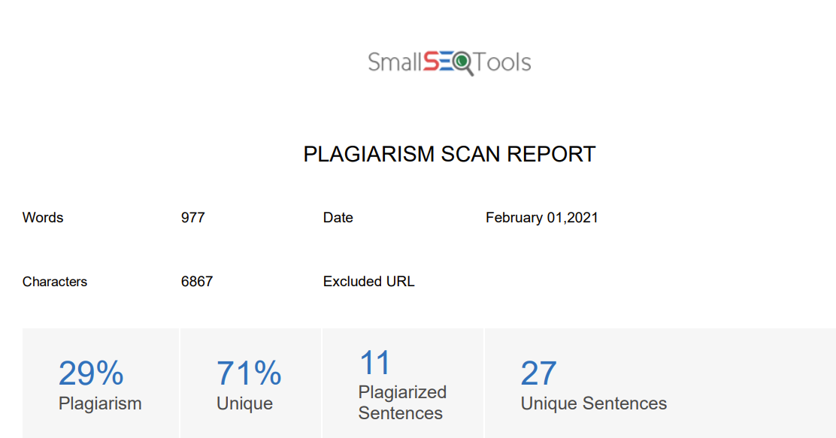

Fig 8.1 – Scan Report